Poetry for the Lockdown

Here’s an interesting resource for this strange time. The idea is you write 100 a day. Not 99 or 101. It has to be 100 words a day for a calendar month. When you’ve completed the month then send the whole transcript to the editors. You’ll need to register and get an account.

One Hundred Words [a month]
https://www.100words.com/batchRead.php

Here’s an idea. Join Amnesty International’s letter/email writing campaign to free prisoners of conscience.
https://www.amnesty.org.uk/

Here’s a good website with a whole range of poems about illness and recovery
https://www.poetryfoundation.org/collections/145189/poems-of-illness-5a319c160b730

Here’s another excellent website that lists a range of poems on the subject of illness.
https://poets.org/text/poems-illness

Here’s an article from The Guardian website posted earlier this month
https://www.theguardian.com/books/2020/apr/12/poem-constructed-from-emails-during-quarantine-goes-viral

Here’s a post on The Independent website titled 10 poems to keep your spirits up during self-isolation by Annie Lord
https://www.independent.co.uk/arts-entertainment/books/features/best-poems-positive-coronavirus-self-isolation-quarantine-a9435951.html

Here are three photographs that struck me as relevant for this time.

Choose a photograph and write a short piece of describing what you see, hear, feel, taste and smell.
Using the same photograph imagine the same scene. Imagine it during normal time – pre lockdown. Write a short piece describing what you can see, hear, feel, taste and smell.

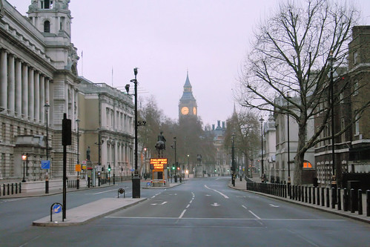

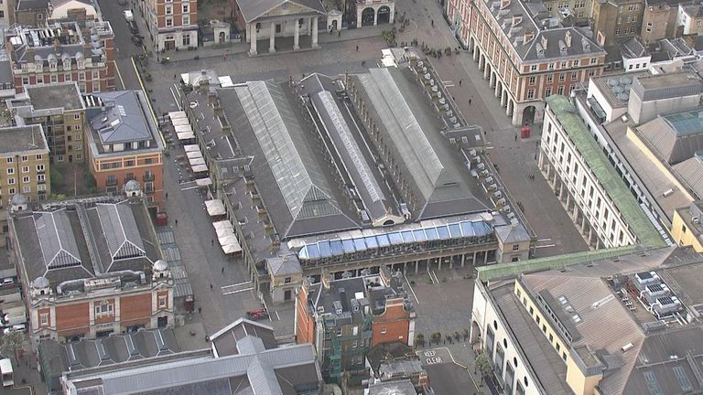

Covent Garden

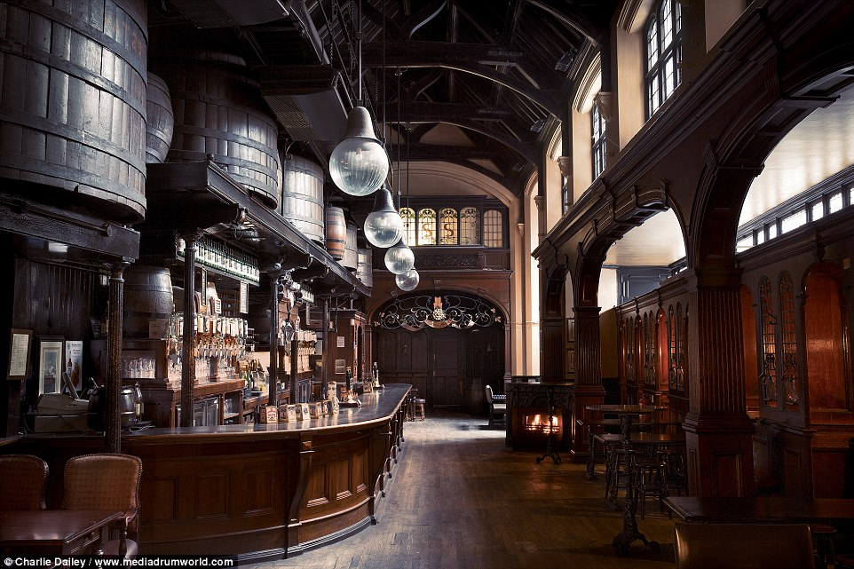

Pub interior

